GSC Canonical Validation & Shopify Markets
Step-by-Step Operations Guide
LEDSone.co.uk — Internal SEO Handover Guide
Purpose: A new SEO/Shopify team member should be able to follow this guide from issue detection through testing, validation, indexing request, and follow-up without changing production settings blindly.
Issue | Duplicate, Google chose different canonical than user
Example URL | https://ledsone.co.uk/pl/
Initial GSC result | User canonical = /pl/ ; Google-selected canonical = /
Live test result | URL available to Google; page can be indexed
Action taken | Request Indexing submitted; validation left running

1. What the GSC issue means
“Duplicate, Google chose different canonical than user” means the site declares one URL as the preferred canonical, but Google has selected another URL as canonical. A URL can still be crawlable and technically indexable while Google chooses a different canonical.
Example:
- Affected URL: https://ledsone.co.uk/pl/
- User-declared canonical: https://ledsone.co.uk/pl/
- Google-selected canonical: https://ledsone.co.uk/

2. Why /pl/ exists on this Shopify store
The Shopify store has multiple Markets. The EU Market includes Poland, while the UK is also an active market. A market/language subfolder such as /pl/ can therefore be a legitimate international URL. Do not remove a market or URL simply because it appears in GSC.
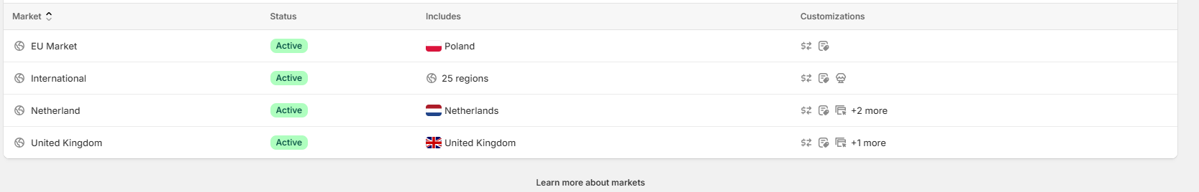
Figure: Shopify Markets configuration shown during the investigation.

3. Key principle: Market ≠ translation
A market defines where/how the store serves customers; translation defines language content. The investigation showed that Polish was being configured separately in Shopify's language/translation settings. Do not install another translation app or change market settings just to remove a GSC URL.
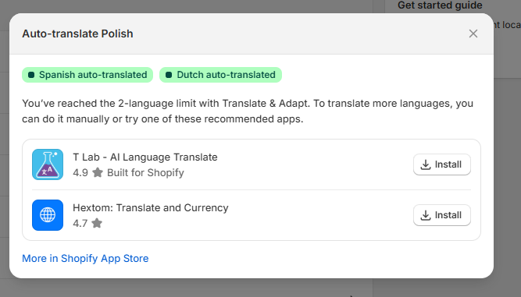

4. Investigation workflow
Step 1 — Identify the affected URL
From GSC, open the issue and choose one representative URL. Start with one URL instead of changing hundreds of URLs at once.
Step 2 — Check Shopify Markets
Confirm whether the country/region is intentionally configured. For this case, Poland was included in the EU Market.
Step 3 — Open the URL
Visit the affected URL directly. Confirm whether it loads, redirects, or errors.
Step 4 — Inspect in GSC
Use URL Inspection and record User-declared canonical and Google-selected canonical.
Step 5 — Inspect live HTML
View Page Source and search for canonical. Confirm what the current storefront actually declares.
Step 6 — Check hreflang
Search the live source for hreflang and confirm that international URLs are connected appropriately.
Step 7 — Run Test Live URL
Use GSC Test Live URL. Confirm crawl allowed, fetch successful, and indexing allowed.
Step 8 — Request Indexing only after verification
If the live page is correct and has changed, request indexing once. Do not repeatedly submit the same URL.
Step 9 — Wait for Google processing
Google-selected canonical may only be determined after indexing. Leave the validation cycle running.

5. Investigation example — /pl/
The actual investigation produced the following evidence:
Check | Observed result
Shopify market | EU Market includes Poland.
Live URL | https://ledsone.co.uk/pl/ loads successfully.
Old GSC crawl | Last crawl shown was 11 Sep 2026.
Old GSC canonical | User-declared /pl/; Google-selected /.
Current source | HTML language is pl and canonical is https://ledsone.co.uk/pl.
Current hreflang | Source contains x-default, en-gb, es, pl, nl and nl-NL alternate links.
Live test | URL available to Google; crawl allowed; fetch successful; indexing allowed.
Live-test canonical | User-declared /pl/; Google-selected canonical is only determined after indexing.
Indexing request | Accepted and added to a priority crawl queue.

6. Canonical testing — exact procedure
Use this checklist for any affected URL:
- Copy the exact URL from GSC.
- Open GSC → URL Inspection.
- Record Page indexing status.
- Record User-declared canonical.
- Record Google-selected canonical.
- Open the live URL in a browser.
- Right-click → View Page Source.
- Ctrl + F → search “canonical”.
- Confirm the canonical href.
- Ctrl + F → search “hreflang”.
- Record relevant language/market URLs.

7. Testing example — what counts as a good live test
- Crawl allowed = Yes
- Page fetch = Successful
- Indexing allowed = Yes
- User-declared canonical matches the intended current URL
- No accidental redirect to the wrong market
Important: A successful live test does not guarantee indexing or guarantee that Google will select the user-declared canonical.

8. What Request Indexing actually does
Request Indexing places the URL into Google's priority crawl queue. Google may recrawl and process the page, but the request does not guarantee indexing and does not guarantee that Google will select the user-declared canonical.
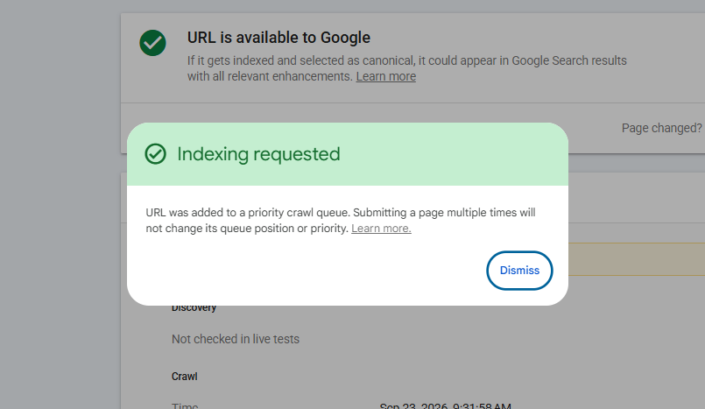

9. Validation: 212 Pending / 0 Failed
The GSC validation started on 23 Sep 2026 and initially showed 212 Pending and 0 Failed. Pending means Google has not completed validation for those URLs. It is not the same as 212 confirmed failures.
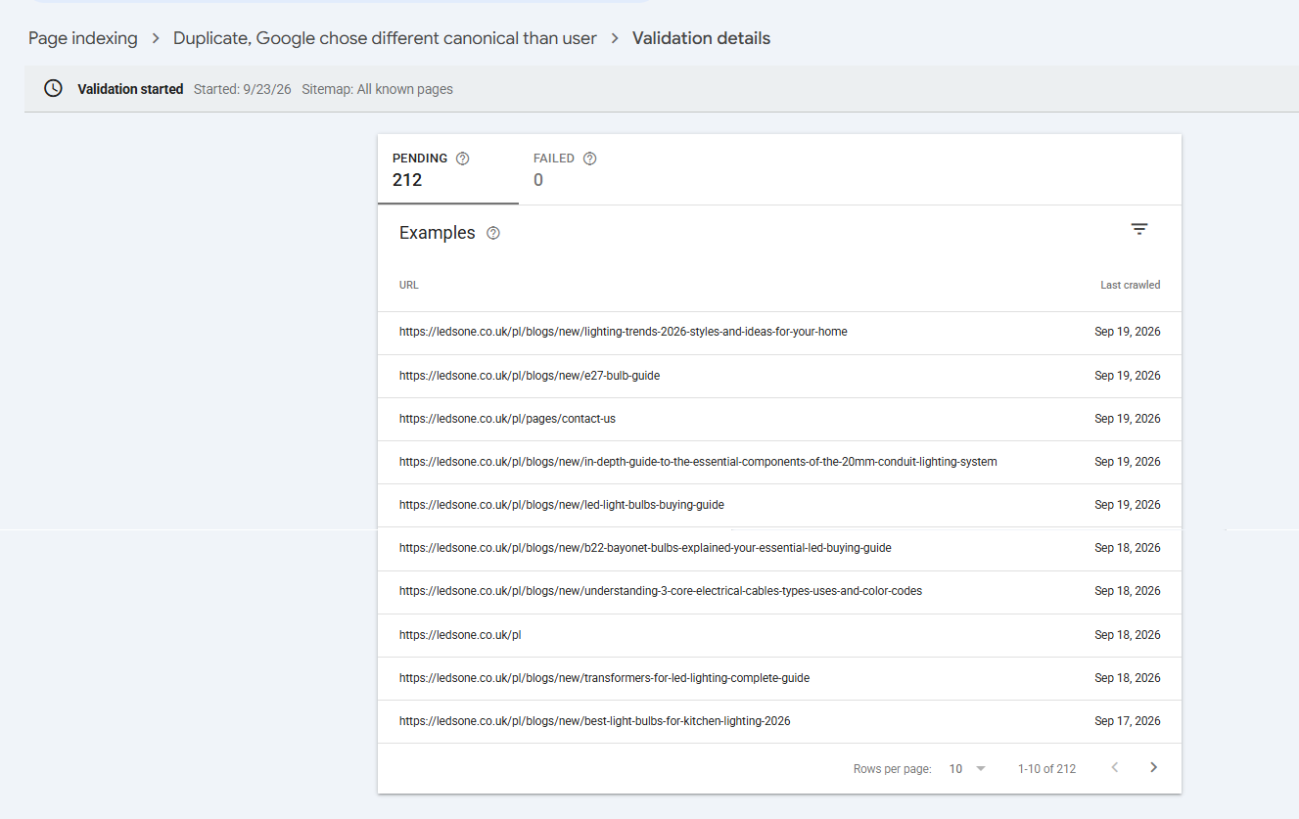
Operational rule: do not restart validation repeatedly. Let Google recrawl the affected URLs. When processing finishes, GSC will report the resulting validation outcome.

10. Before/after evidence examples
Screenshot 1 — GSC validation: 212 Pending, 0 Failed.
Screenshot 2 — Shopify Markets: EU Market includes Poland; UK is also active.
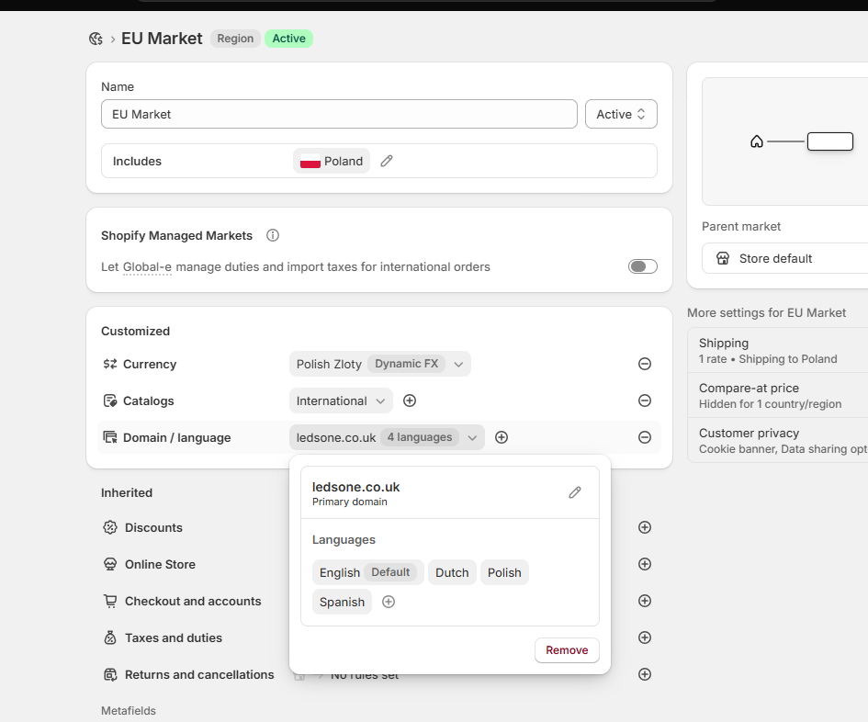
Screenshot 4 — EU Market / Poland configuration showing ledsone.co.uk and available languages.
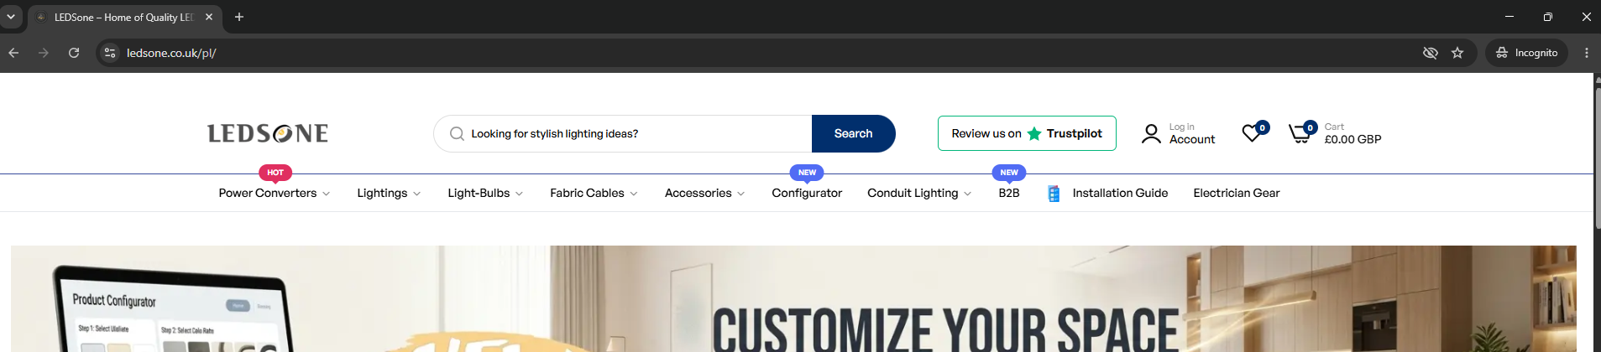
Screenshot 5 — Live /pl/ URL loads successfully.
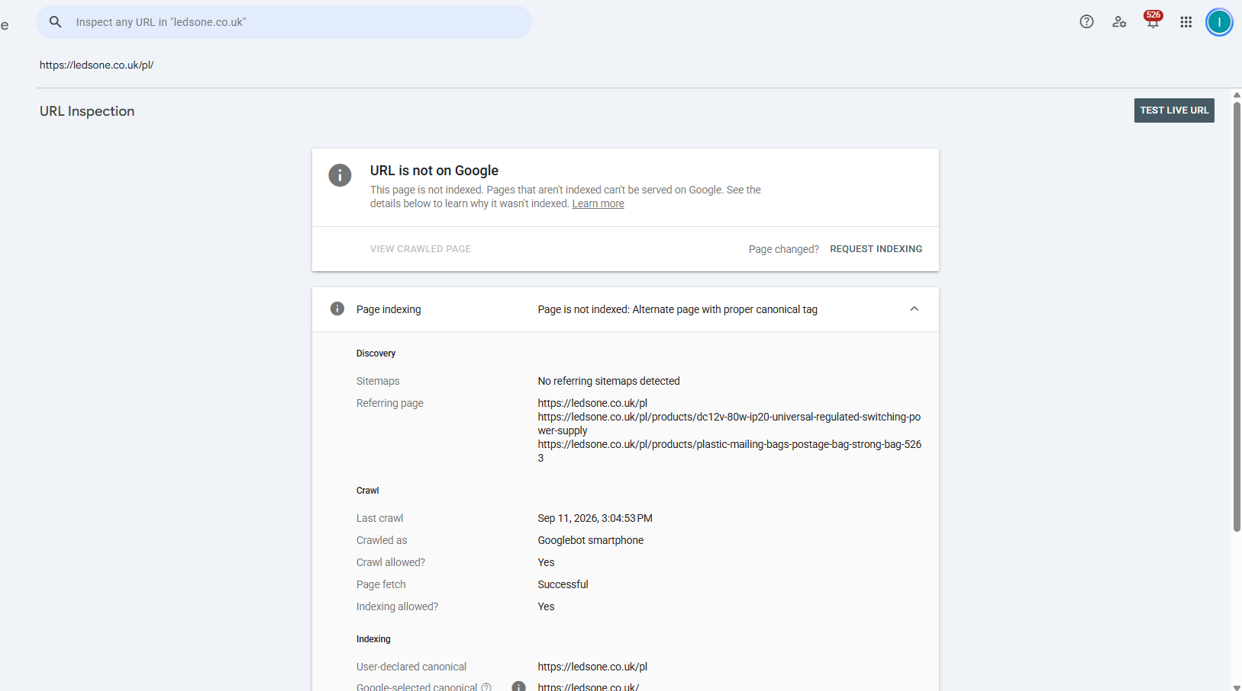
Screenshot 6 — GSC URL Inspection: /pl/ not indexed; alternate page with proper canonical tag; user canonical /pl/ and Google-selected /.
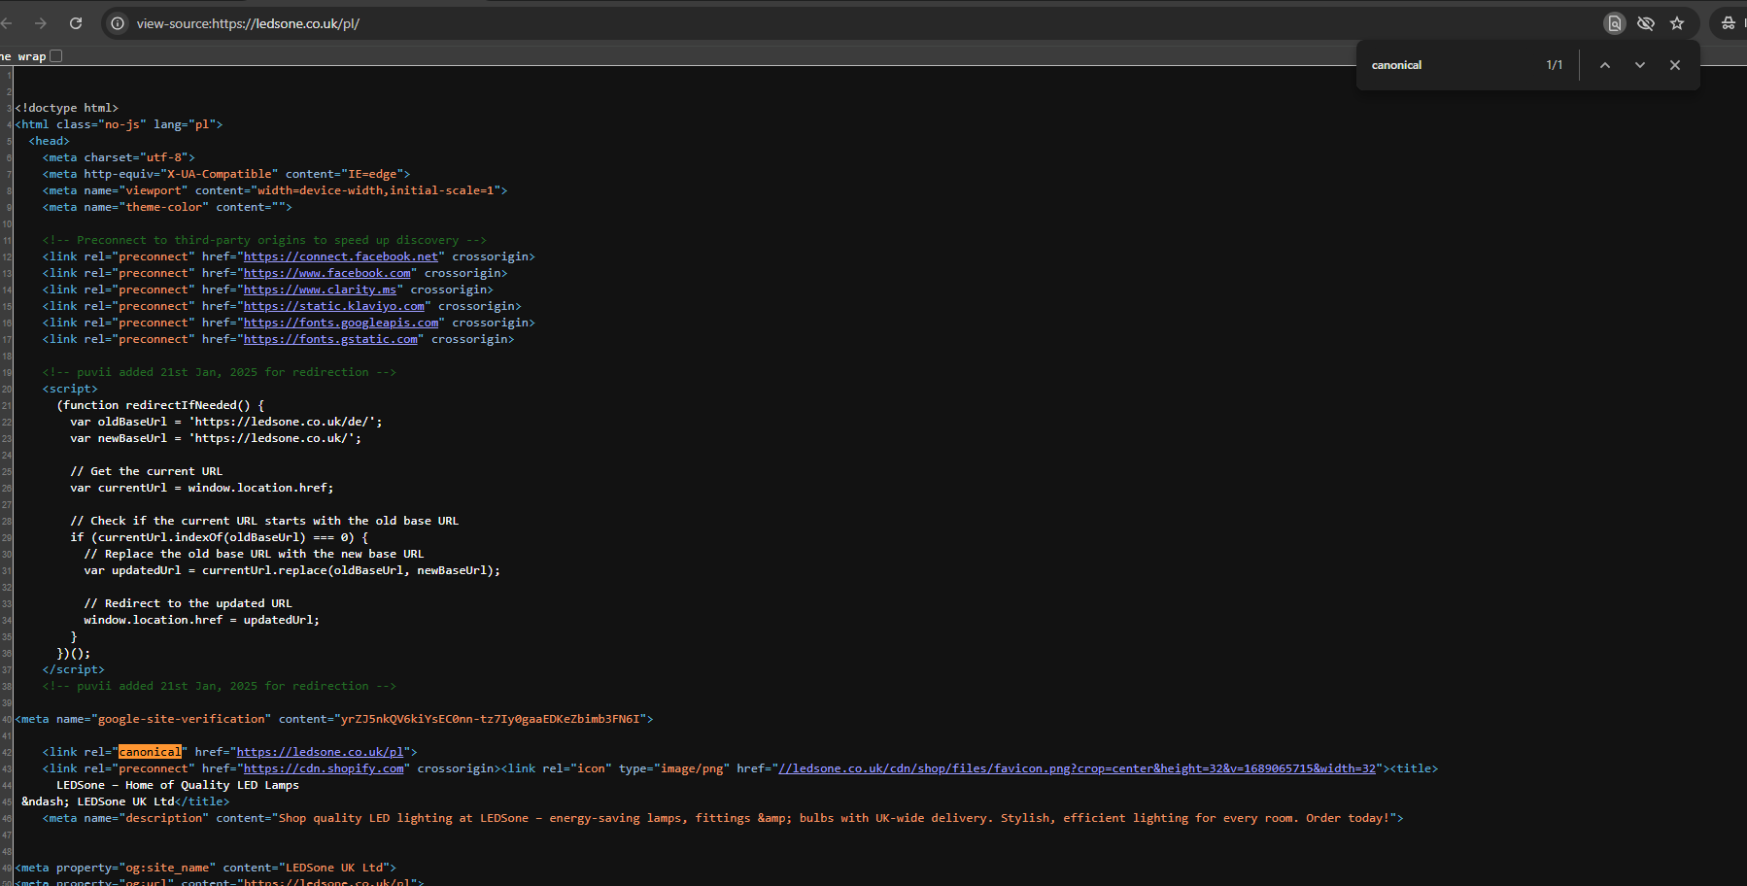
Screenshot 8 — Live page source: lang=pl and canonical https://ledsone.co.uk/pl.
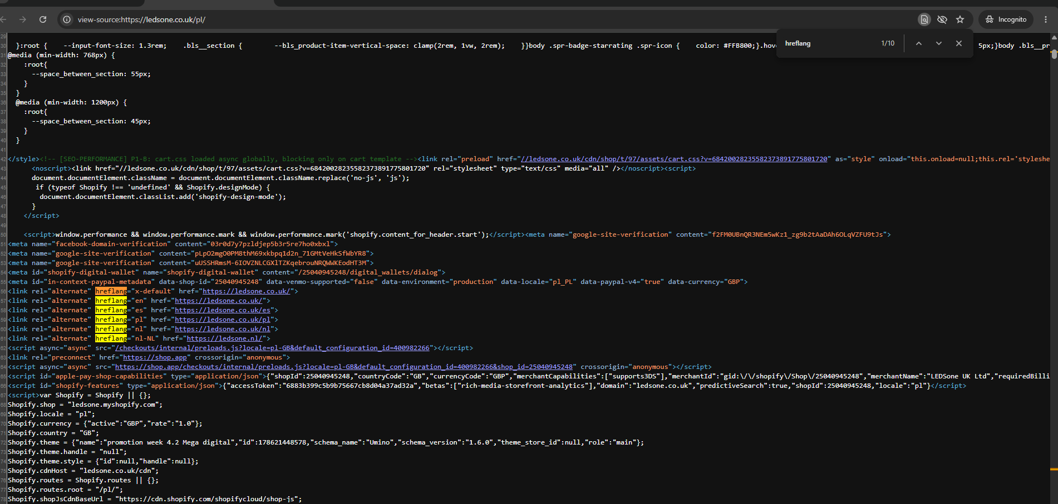
Screenshot 9 — Live page source: hreflang entries including en-gb, es, pl, nl and nl-NL.
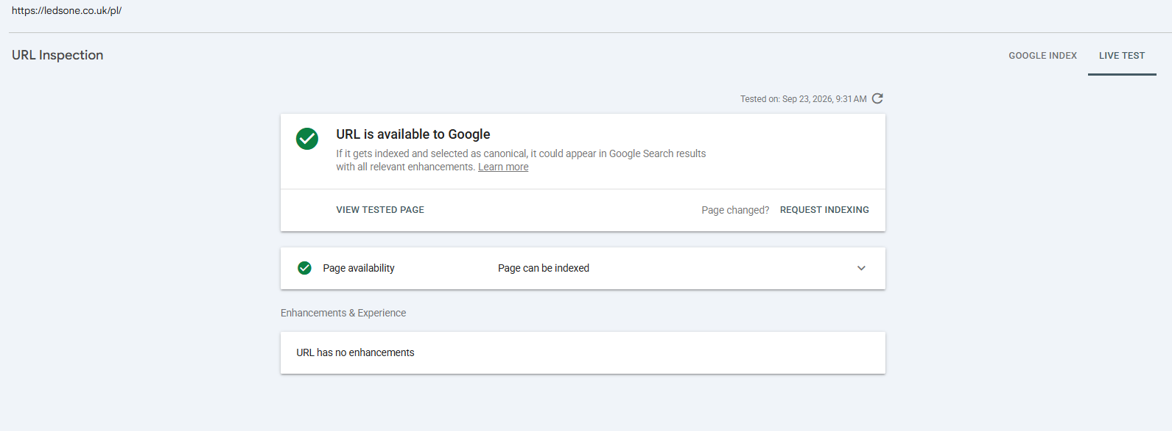
Screenshot 10 — GSC Live Test: URL is available to Google; page can be indexed.
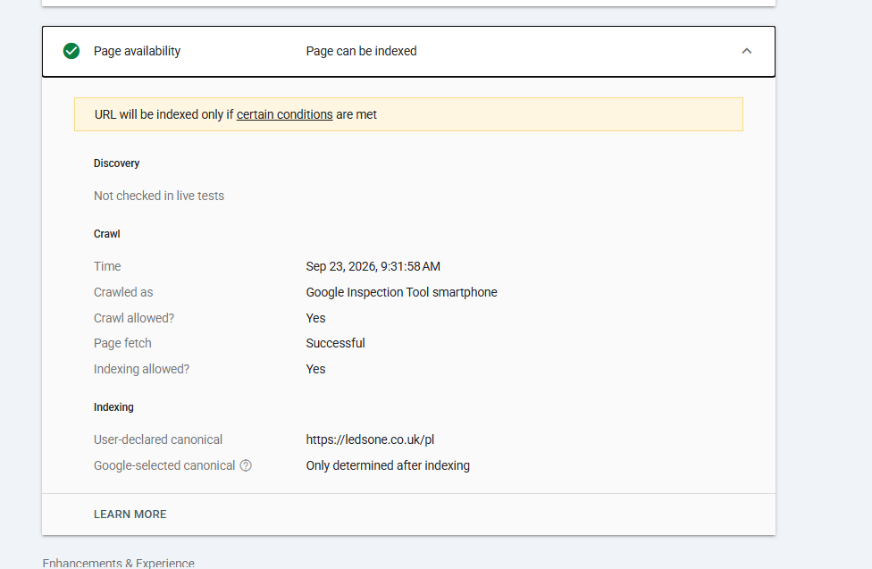
Screenshot 11 — Live Test details: crawl/fetch/indexing allowed; user canonical /pl/; Google-selected canonical only determined after indexing.

11. Do NOT do these actions without evidence
- Do not remove Poland from Shopify Markets just because /pl/ appears in GSC.
- Do not delete /pl/ or add noindex blindly.
- Do not change canonical tags across hundreds of pages based on one example.
- Do not remove hreflang without checking the market/language structure.
- Do not install a new translation app just to solve a canonical report.
- Do not repeatedly request indexing for the same URL.
- Do not restart GSC validation simply because many URLs are still Pending.

12. Troubleshooting decision tree
Situation | Next action
URL does not load | Fix accessibility/redirect/server issue first.
URL redirects unexpectedly | Check Shopify market/domain/redirect configuration before changing canonical.
Canonical missing | Investigate theme/Shopify canonical implementation.
Canonical points to another URL intentionally | Confirm that the target is actually the intended canonical.
Canonical is correct but Google selects another | Check duplicate content, internal links, sitemap signals, redirects, hreflang and other conflicting signals before changing code.
Live test is correct but Google-selected canonical is not shown | Normal during live testing; Google may determine it after indexing.

13. New employee checklist
☐ Understand what canonical means.
☐ Identify the affected URL.
☐ Check Shopify Markets before changing anything.
☐ Confirm whether the URL is an intentional market/language URL.
☐ Inspect User-declared and Google-selected canonical in GSC.
☐ Check live HTML canonical.
☐ Check hreflang.
☐ Run Test Live URL.
☐ Request Indexing only after the live setup is verified.
☐ Leave validation running.
☐ Record evidence/screenshots in the SEO work log.

14. Recommended evidence record template
Field | Value
Date | YYYY-MM-DD
Affected URL
GSC issue | Duplicate, Google chose different canonical than user
User-declared canonical
Google-selected canonical
Shopify Market
Language
Live canonical tag
Hreflang observed
Live test | Pass / Fail
Request indexing | Yes / No
Validation status
Next review date

15. Current case status — LEDSone /pl/
- Poland is configured as part of the EU Market.
- The /pl/ URL loads successfully.
- The live page declares /pl/ as canonical.
- The live page has lang="pl".
- The live page contains hreflang entries including pl.
- GSC live test says the URL is available to Google and can be indexed.
- Request Indexing was accepted.
- GSC validation remains in progress; 212 URLs were pending at the time of the screenshot.
Next monitoring action: re-inspect /pl/ after Google processes the indexing request and check the eventual Google-selected canonical. Do not make additional production changes unless new evidence shows a configuration problem.

